CST 229 – Lecture 4
Wilsonville, Fall 2017

Ch 12-13, CFG, symbols, productions, derivations, parse trees, CNF

Before we dive into “CFG”s, we need to understand a bunch of concepts…

Programming language – A language that humans can use to create programs, not directly executable on any particular machine, e.g. C, C++, C#, Java…

Syntax – The structure of a program written in a programming language
Semantics – The meaning of a program written in a programming language

Compiler – A program that translates a program, written in a human-readable programming language, into an equivalent program that is executable on a given machine

Parser – Part of a compiler that groups symbols from of an input program into syntactically correct sentences for later parts of the compiler

Grammar – A formal definition of a programming language, useful for expressing the syntactical rules of the language in a way that allows programs to be parsed

Symbol – Used in defining grammars, may be terminals or non-terminals
Terminal – Symbol representing an actual symbol found in input programs
Non-Terminal – Symbol representing a place-holder defined and used in grammar rules

Production – Rule in a grammar that generates part of a valid sentence in the language

Finally…

Context-Free Grammar is a grammar in the following form:
- T is a finite set of terminal symbols
- N is a finite set of non-terminal symbols
- S is a unique starting symbol, S must be in N
- R is a finite set of productions of the form “A → s”,
where A is a non-terminal and s is a string of non-terminals and/or terminals

Think of productions as replacements, where you can replace the non-terminal on the left with the string on the right while generating a valid sentence in the language

Productions can use OR, ‘|’, as a short hand

S → A
S → B

is equivalent to…
S → A | B

Lambda-Productions represent optional parts of a sentence, e.g. A → λ
Example CFG:
Terminals T = {i, +, *}
Non-terminals N = {E}
Starting Symbol S = E
Productions R =
{
E → E + E
E → E * E
E → i
}

Typically, we’ll just write this like so…
E → E + E
E → E * E
E → i
… assuming that E is the starting symbol, because it’s listed first in the productions, and that all terminal and non-terminals are evident in the productions.

Or, more compactly…
E → E + E | E * E | i

Derivations – Specific sequence of applying productions that generates a valid sentence
Left-most Derivation – Always replace the left-most non-terminal at each step
Right-most Derivation – Always replace the right-most non-terminal at each step

Example left-most derivation, using grammar above…
E
E + E
E * E + E
i * E + E
i * i + E
i * i + i

Example right-most derivation…
E
E * E
E * E + E
E * E + i
E * i + i
i * i + i

Wait! What the heck does this actually mean?

Imagine that the terminal symbol ‘i’ can stand in for any variable name, like x, y or z
This grammar is generating valid “expressions”, e.g. x * y + z

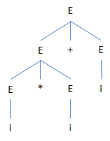
Parse Tree – Graphical representation of a derivation, where non-terminals are the interior nodes, and terminals are the leaves

Example parse tree…
E
E + E
E * E + E
i * E + E
i * i + E
i * i + i

Ambiguity
A grammar in which it is possible to produce more than one left-most or more than one right-most derivation for the same sentence is ambiguous

Warning: Ambiguity is unacceptable in a compiler!

Is the expression grammar ambiguous?
E → E + E | E * E | i

Consider the sentence “i + i * i”

Left-most Derivation 1
E
E + E
i + E
i + E * E
i + i * E
i + i * i
Left-most Derivation 2
E
E * E
E + E * E
i + E * E
i + i * E
i + i * i

What do these look like in parse trees?
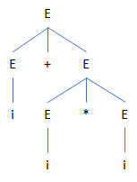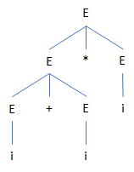
Do they have the same semantic meaning?
Resolving ambiguity requires rewriting the grammar
For example, we can rewrite the expression grammar like so…

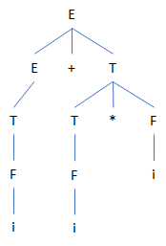
E → E + T | T
T → T * F | F
F → i

Left-most derivation for “i + i * i”:
E
E + T
T + T
F + T
i + T
i + T * F
i + F * F
i + i * F
i + i * i

There is no way in this grammar to create a different, but equivalent, left-most derivation

Chomsky Normal Form (CNF)
For any CFG, there is an equivalent CFG, where all productions are one of two types:
S → AB, where A and B are non-terminals
S → a, where a is a single terminal

Note: Useful for doing proofs with CFGs, but not easy to construct
For example, try to rewrite the unambiguous expression syntax above as a CNF (enjoy!)

Context-Free Language – Any language that can be defined by a CFG

Regular Languages are Context-Free Languages
Given a RE or FA, there exists an equivalent CFG

Not all Context-Free Languages are Regular Languages

Examples of Nonregular, but Context-Free, languages that can be defined by CFGs:

L = {a^{n} b^{n}, where n = 0, 1, 2…}
S → a S b
S → λ

In class, try some derivations to see what we get…

Palindrome:
S → a S a
S → b S b
S → a | b | λ

In class, try some derivations to see what we get…

Balanced Parenthesis:
Example sentences… ( ), (( )), ( ) ( ), (( ) ( ))

In class, create CFG for this and try to generate the example sentences

